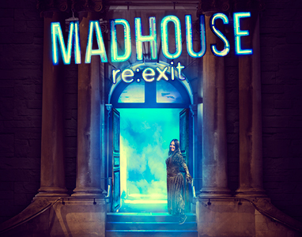 | Access All Areas  MADHOUSE RE:EXIT
Access Booking Form

If you have any access requirements, please complete this form.

This will help us to make sure all audience members can enjoy the show.

Please answer the questions below by ticking the yes or no box.

Why are we asking you to fill at this form?

Access All Areas is committed to
ensure that each audition member is respected as an individual, with their own access needs, communication styles, and self-identification, by ensuring that all access requirements are met.

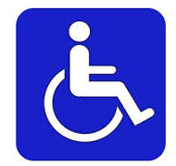 | Do you require wheelchair access?  ☐ Yes  ☐ No
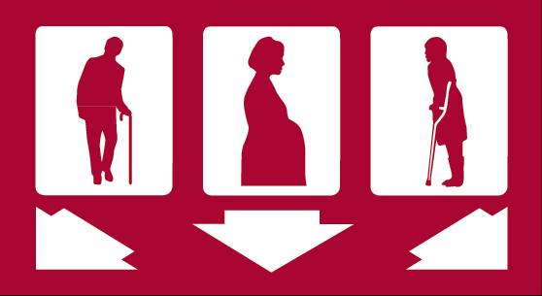 | Do you have limited mobility that would restrict walking distance, standing time or navigating steps?  ☐ Yes  ☐ No
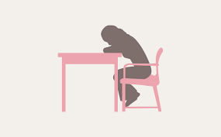 | Do you have fatigue or other issues that would affect not having fresh air for a long period of time?  ☐ Yes  ☐ No
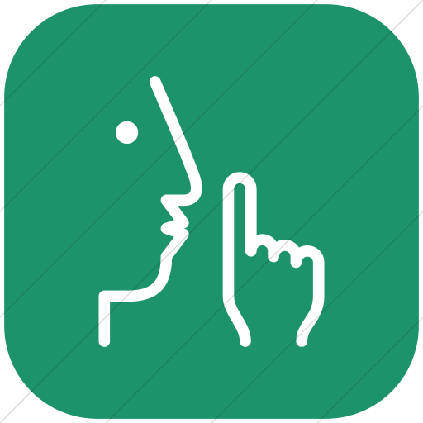 | Do you require a quiet space?  ☐ Yes  ☐ No
Do you require a BSL interpreter?

☐ Yes

☐ No
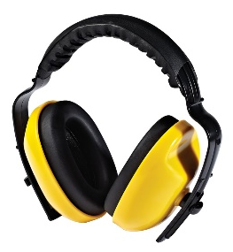 | Do you require ear defenders due to loud bangs and noise?  ☐ Yes  ☐ No
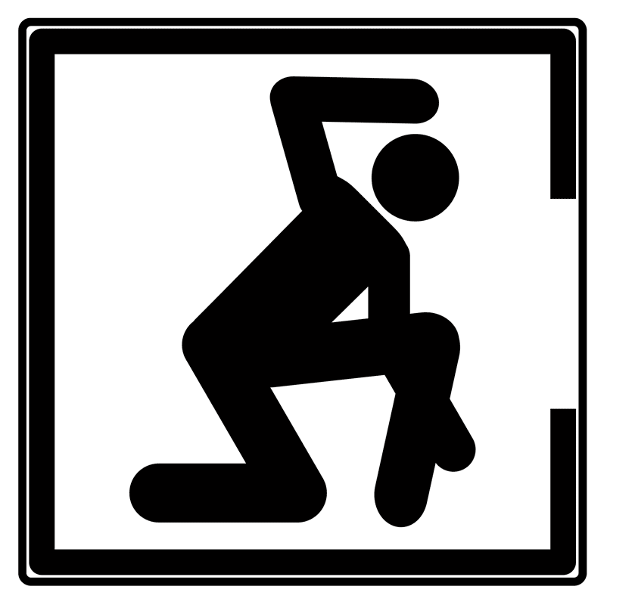 | Do you find it difficult being in small, enclosed spaces?  ☐ Yes  ☐ No
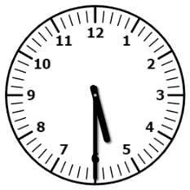  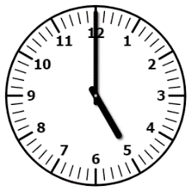  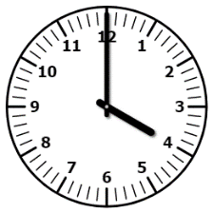  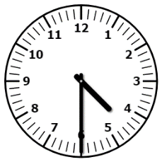 | We will be running familiarisation tours where you can see and touch the set before the show.  If you think this would be helpful to you, please tell us which date you would like to come.  ☐ Friday 16th March  Time: 4pm – 4.30pm  ☐ Tuesday 20th March  Time: 5pm – 5.30pm  ☐ Monday 26th March  Time: 5pm – 5.30pm
Please tell us if you need assistance completing this form or wish to discuss your access needs directly with us.

Please call reception on 020 7739 6176

Or Email:

marketing@shoreditchtownhall.com

Please return this form to address below:

Shoreditch Town Hall, 380 Old Street, London, EC1V 9LT

Or email:

marketing@shoreditchtownhall.com

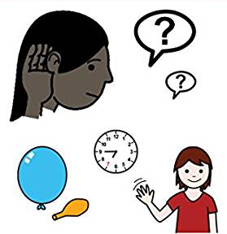 | You may also want to look at  MADHOUSE re:exit Visual Guide  This will give you information about what to expect in the show.

Many thanks, from Access All Areas.
Thank you. We hope you enjoy the show.

