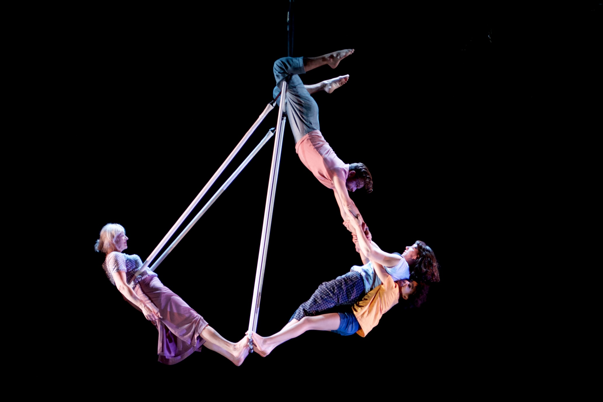
YOUR VISIT TO
HE AIN’T EAVY

AT
Shoreditch Town Hall
Relaxed Performances
Sunday 12th January 2020
Social Story
Welcome to Shoreditch Town Hall. Inside you will see a performance of “THIS TIME”. This is what the front of Shoreditch Town Hall looks like:
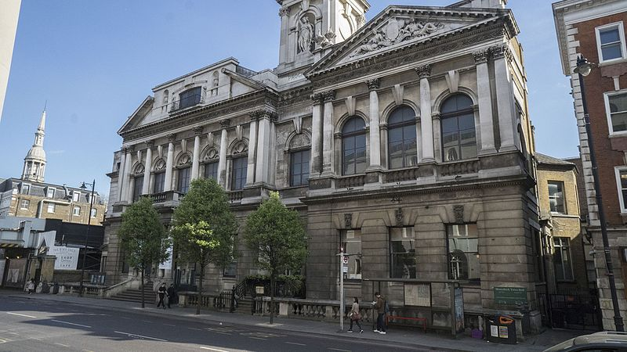

Remember to collect your tickets from the box office if you haven’t already received them. You might need to wait in a queue.
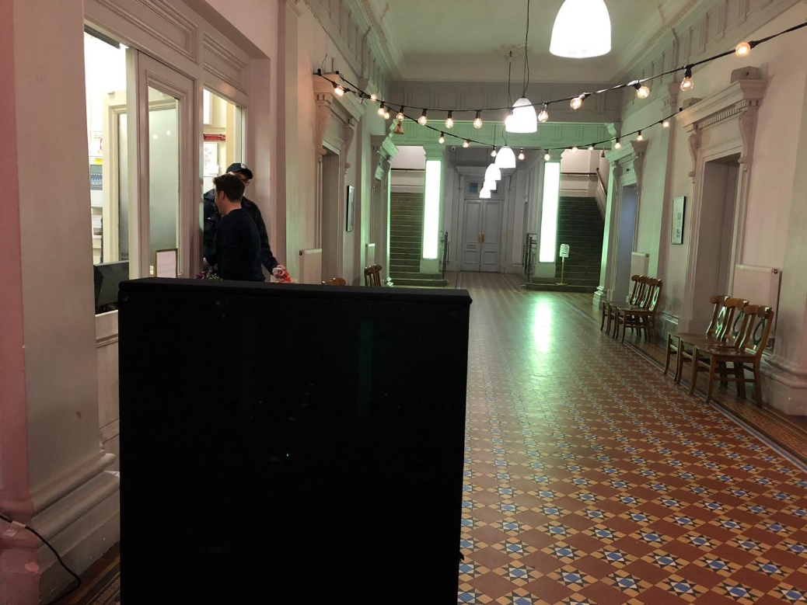

This is what the theatre looks like where you will watch the performance. You can move around or talk if you need to. You can also leave the theatre and go to a chill out space if you need a break.

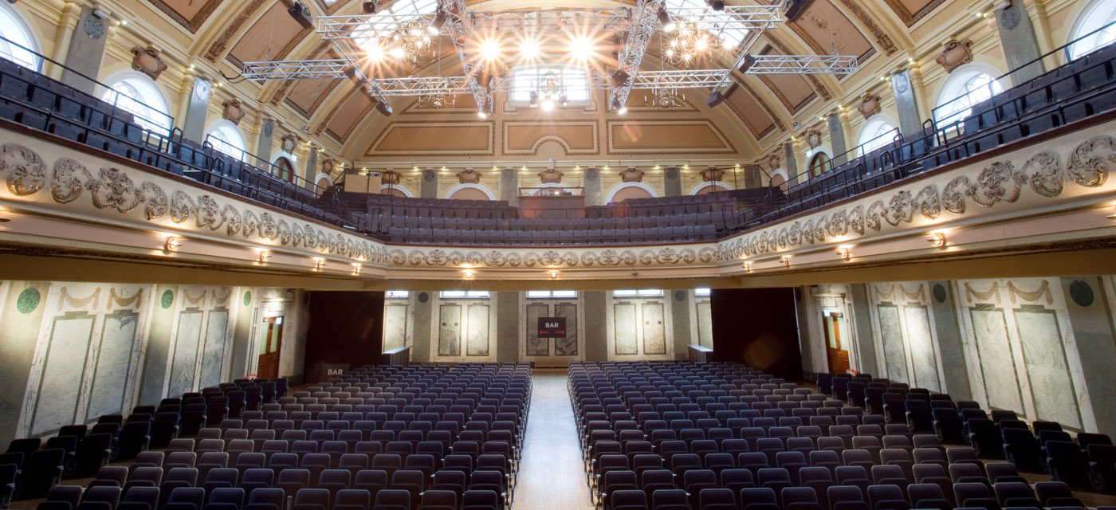

These are the toilets. You can use them before, during and after the performance.
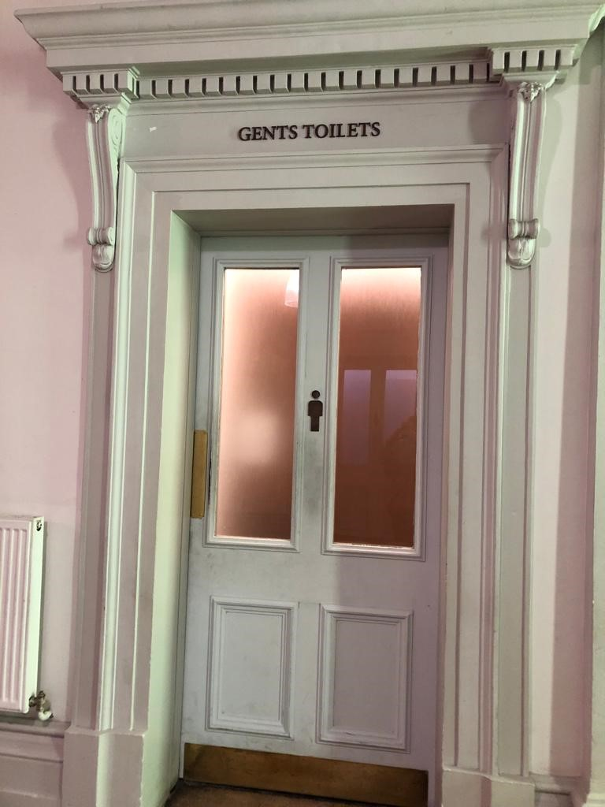
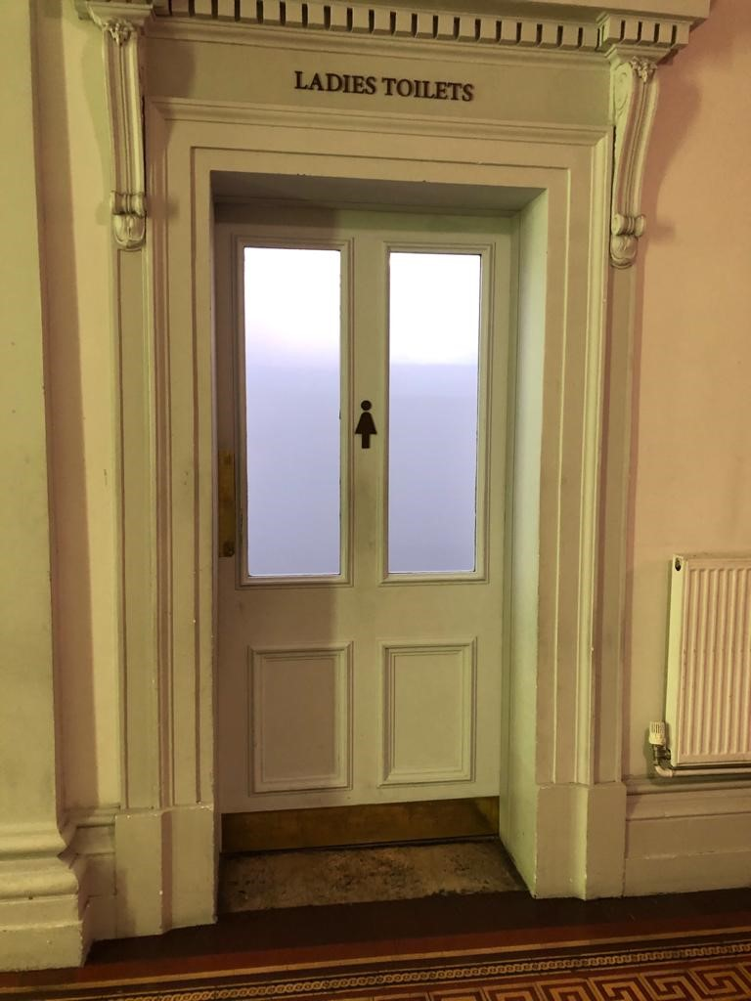

During the performance, if it is too noisy, you can cover your ears or wear ear defenders. You can also go to the chill out space.

It is okay to feel happy or sad during the performance. Other people might too. They may laugh or cry depending on how they feel. This is OK.

During the show you will see 4 people on stage. They are the performers. Their names are Alex, Charlotte, Lee and Faith.
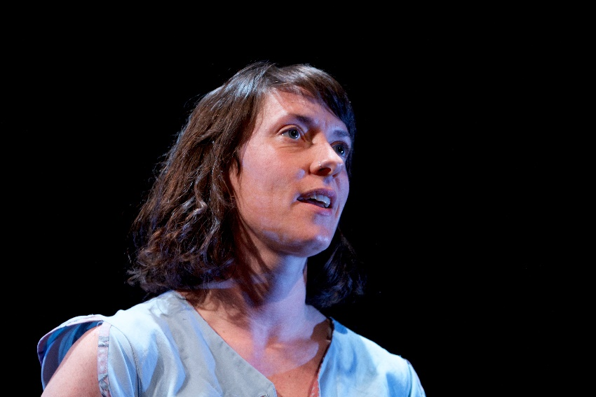
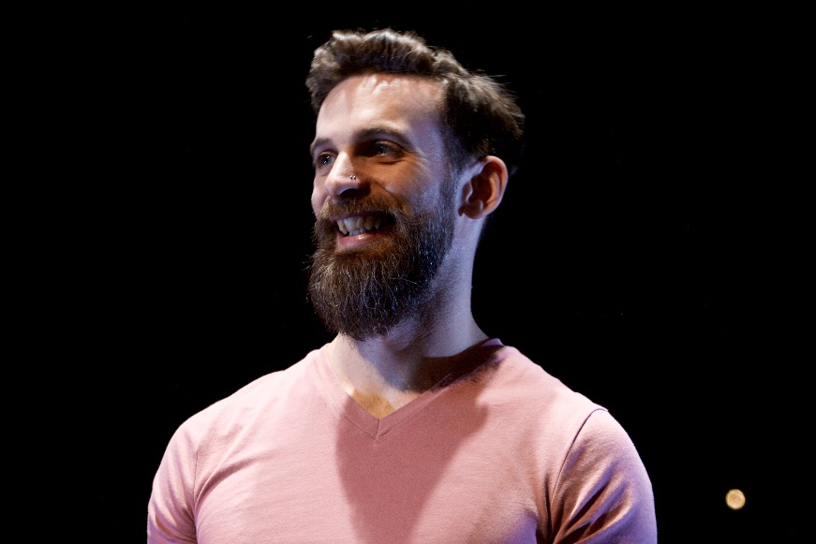

Faith
Lee
Charlotte
Alex
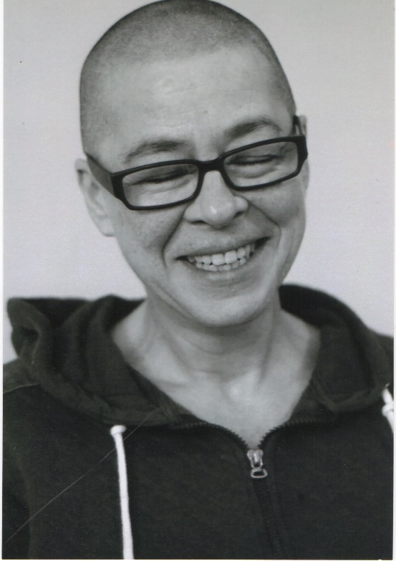
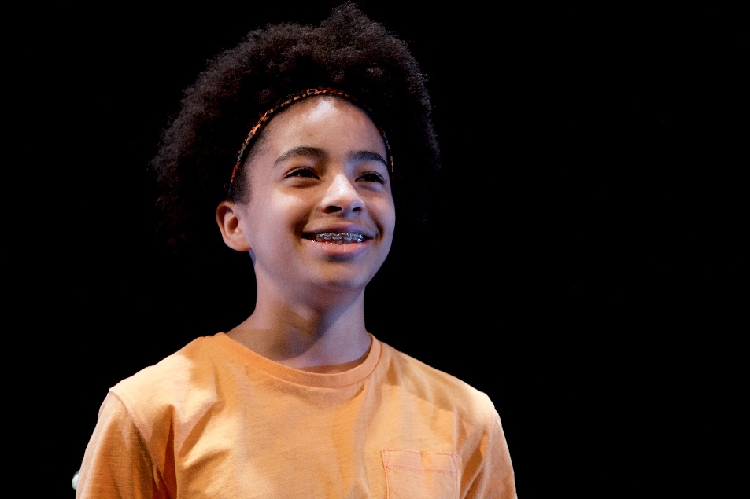
Some other people who help the performers are the producers, production manager and stage manager. Their names are Ali, Stacey and Laura.
Laura
Stacey
Ali
The show starts when the lights dim and you see Charlotte and Faith on stage looking through a white frame.

The show tells you stories about growing up and the performers will tell you personal stories from their lives. When they speak they will often speak to the audience, you do not need to reply.

Throughout the show there are frames and ropes which will get lowered in and raised out of the stage.
These will be moved by the performers on stage and the stage manager who is off stage in the wings.

The performers use the frames and ropes to climb and dance on, sometimes they will move whilst the performers are on them. This is nothing to worry about. The performers are safe.

Sometimes only 1 or 2 of the performers will be on stage at a time. Other times they will all be on stage together. Don’t worry they will always come back and you will see them at the end of the show.

Alex and Charlotte will sometimes do movements that look like they are going to fall. Don’t worry, they are safe and no one will get hurt any jumping and swinging is planned.

Sometimes the lights will get less bright and there will be music or sound effects playing in the background.

If the show is too loud you can wear headphones or put your fingers in your ears. If you need a break, you can leave the theatre at any time and go to the chill out area.
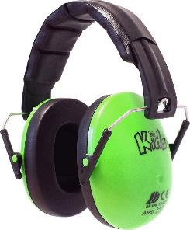

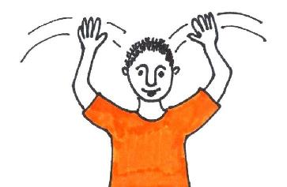
When the show is finished people will clap their hands to say thank you to the performers. You can clap your hands or wave your hands in the air if you want to. Or if you don’t like the noise, you can cover your ears with your hands.

After the show you can exit the theatre. You can meet Alex, Charlotte, Lee & Faith in the Foyer.

