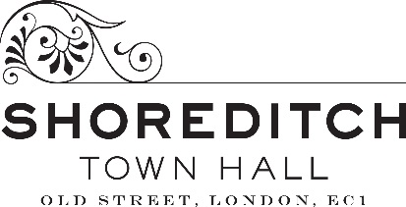

Equal Opportunities Form

Shoreditch Town Hall is committed to access, diversity and representation and we believe that our programmes, workforce and organisational culture should genuinely reflect the range of backgrounds, perspectives and cultures that make up the communities we serve in Shoreditch, Hackney and beyond.

We welcome applications from people of any colour, race, nationality, ethnic origin, religion, socio-economic background, marital status, sex, sexual orientation, age or disability. We aim to ensure all job applicants and employees are treated equally and fairly and are recruited, selected, trained and promoted on the basis of the requirements of the job, their skills, abilities and other job-related criteria.

Please ensure that you complete this Equal Opportunities Form and return it with your application. If you would prefer not to answer some or all of these questions, please simply write ‘Prefer not to say’ in the necessary box(es). This information will be used for monitoring purposes only and will be separated from your application before the selection process.

What vacancy are you applying for? | Chief Executive Officer
Where did you first hear about this vacancy?
How would you describe your gender?  Delete as appropriate | Female  Male  Non-Binary  Trans  None of the above (please specify)
How would you describe your sexual orientation?  Delete as appropriate | Asexual  Bisexual  Heterosexual  Homosexual  Pansexual  None of the above (please specify)
How would you describe your relationship status?  Delete as appropriate | Civil Partnered  Divorced  Married  Single  Widowed  None of the above (please specify)
Do you have any caring responsibilities? | Yes / No
How would you describe your ethnic identity?  Delete as appropriate | Black  Black African  Black British  Black Caribbean  None of the above (please specify)  East Asian  British  Chinese  Japanese  Korean  None of the above (please specify)  Mixed  Black African and White  Black British and White  Black Caribbean and White  East Asian and White  South Asian and White  None of the above (please specify)  South Asian  Bangladeshi  British  Indian  Pakistani  None of the above (please specify)  White  British  English  Gypsy or Irish Traveller  Irish  Scottish  Welsh  None of the above (please specify)  None of the above (please specify)
Do you consider yourself to have a disability?  In accordance with the Equality Act 2010, a disability is defined as a physical or mental impairment which has a substantial and long-term adverse effect on a person’s ability to carry out normal day-to-day activities. | Yes / No  If Yes, please state the disability and/or any reasonable adjustments we need to consider making if you are invited to attend an interview.
Which socio-economic group do you perceive you belong to at this stage in your life?

This is often defined as working class, middle class or upper class, however please don’t feel limited by these definitions.

